Evoked Potentials and GCP Event Data

Roger D. Nelson

Director, Global Consciousness Project
http://global-mind.org

Abstract
Signal averaging can reveal patterns in noisy data from repeated-measures experimental designs. A widely known example is mapping brain activity in response to either endogenous or exogenous stimuli such as decisions, visual patterns, or auditory bursts of sound. A common technology is EEG or other monitoring of brain potentials using scalp or embedded electrodes, Evoked potentials (EP) are measured in time-locked synchronization with repetitions of the same stimulus. The electrical measure in raw form is extremely noisy, reflecting not only responses to the imposed stimulus but also a large amount of normal, but unrelated activity. In the raw data no structure related to the stimulus is apparent, so the process is repeated many times, yielding multiple epochs that can be averaged. Such “signal averaging” reduces or washes out random fluctuations while structured variation linked to the stimulus builds up over multiple samples. The resulting pattern usually shows a large excursion preceded and followed by smaller deviations with a typical time-course relative to the stimulus.
The Global Consciousness Project (GCP) maintains a network of random number generators (RNG) running constantly at about 60 locations around the world, sending streams of 200-bit trials generated each second to be archived as parallel random sequences. Standard processing for most analyses computes a network variance measure for each second across the parallel data streams. This is the raw data used to calculate a figure of merit for each formal test of the GCP hypothesis: we predict non-random structure in data taken during “global events” that engage the attention of large numbers of people. The data are combined across all seconds of the event to give a representative Z-score, and typically displayed graphically as a cumulative deviation from expectation showing the history of the data sequence. For the present work, we treat the raw data in the same way measured electrical potentials from the brain are processed to reveal temporal patterns. In both cases the signal to noise ratio is very small, requiring signal averaging to reveal structure in what otherwise appears to be random data.
Applying this model to analyze GCP data from events that show significant departures from expectation, we find patterns that look like those found in EP work. While this assessment is limited to visual comparisons, the degree of similarity is striking. It suggests that human brain activity in response to stimuli may be a useful model to guide further research addressing the question whether we can observe manifestations of a world-scale consciousness analogue.

Introduction
Since the middle of last century, brain science has been developing sophisticated ways of tapping into neurological activity to learn more about how the brain accomplishes the remarkably complex manifestations of human consciousness. The work is specialized because there are so many kinds of questions, and most answers raise more questions. A major area of research uses measures of electrical potentials as they vary during activity of the brain. One of the most familiar technologies is Electroencephalography (EEG) research, with multiple electrodes arrayed over the scalp to capture brain activity corresponding to experiences and activities of the human subject. A sharply focused subset of that technology uses fewer electrodes (an active and reference pair at minimum) to record neural responses from a limited region. Examples are visual evoked responses to a flash of light or an alternating checkerboard pattern, and auditory evoked responses to sound bursts or patterns. The electrical data recording is synchronized to the stimulus onset or pattern, so analysis of the data can identify the onset of the stimulus and track the evoked response over time. Because the data are very noisy, signal averaging is used to compound the data over many epochs. This washes out the unstructured background noise while gradually building up an averaged response to the repeated stimulus. Results are typically presented as a graphical display where variations of the sequential data can be seen in relation to the time of the stimulus.
In this paper we ask a similar question of event-related segments within the database recorded by the GCP over the past two decades. The data are parallel random sequences produced by a world-spanning network of RNGs that record a trial each second comprising 200 random bits. The result is a continuous data history that parallels the history of events in the world over the same 20 years. The GCP was created to ask whether big events that bring large numbers of people to a common focus of thought and emotion might correspond to changes or structure in the random data. Specifically, the hypothesis to be tested states that we will find deviations in random data corresponding to major events in the world. This general hypothesis is instantiated in a series of formal tests applied to events that may engage the attention and emotions of millions of people around the world. For each selected event, analysis parameters including the beginning time, end time and the statistic to be used are registered before any examination of the data. Over the period from 1998 to 2016, 500 individual tests were accumulated in a formal series whose meta-analysis constitutes the test of the general hypothesis. The bottom line result shows a small but persistent effect with a Z-score averaging about 1/3 of a standard deviation. Though small, the accumulated result over the full database is a 7-sigma departure from expectation, with trillion to one odds against it being chance fluctuation, This robust bottom line indicating there is structure in the data supports deeper examination that may illuminate the sources and implications of the anomalies.

Data Characterization
The analysis used for most GCP events is straightforward. For each second, the standardized Z-scores for each RNG in the network are composed as a Stouffer’s Z-score, which is an average across roughly 60 RNGs expressed as a proper Z-score. This is squared, to yield a Chisquare with 1 degree of freedom that represents the network variance (Netvar) for that second. These are summed across all seconds in the event and normalized to yield a final score. Algebraically, the Netvar calculation is closely approximated by the excess pairwise correlation among the RNGs for each second. With 60 or 65 RNGs reporting, there are approximately 2000 pairs, so this estimate of deviation is robust. Additionally, the pairwise calculation carries more information and allows examination of questions that the simpler measure of composite network variance can’t accommodate. For our purposes here, however, the Netvar measure is sufficient. We use all the data – the second-by-second scores – representing the longitudinal development during each specified event. In other words, we will be examining the time-series character of the data sequences that define the events.

Data display
The GCP frequently uses a “cumulative deviation” graph to show the data corresponding to an event selected because it engages mass attention. This type of display was developed for use in process engineering to facilitate detection of small but persistent deviations from the norms specified in manufacturing parameters. It plots the sequence of positive and negative deviations from the expected value as an accumulating sum that shows a positive trend if there are consistent positive deviations, and similarly for negative deviations. It looks somewhat like a time series, but because each point includes the previous points, it is autocorrelated (which emphasizes persistent departures). Cumulative deviation graphs are well suited to showing the typically tiny differences from expectation in our data and emphasizing any signal that may be present. The technique mitigates random variation while summing consistent patterns of deviation, thus raising signals out of the noise background.
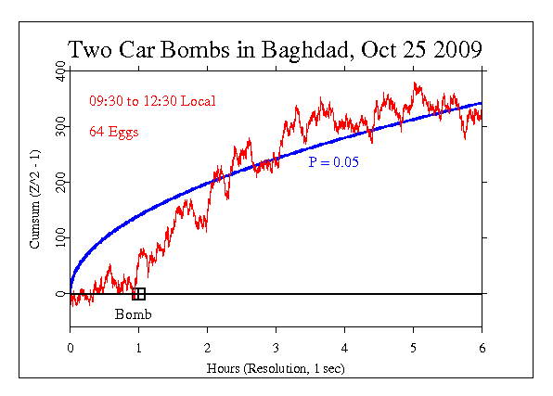
It will be helpful to look at an example of an event shown graphically in this format. The following figure represents the GCP network response to a terrorist bombing in Iraq. It was a global event in the sense that people all around the world were brought to attention and shared emotional reactions. To an unusual degree the thoughts and emotions of millions of people were synchronized. It was a moment in time when we were recruited into a common condition by a major event on the world stage. The event was specified with a duration of 6 hours. This is the most commonly defined event period, which is typically used when something happens that has a well-defined moment of occurrence. The initiating event, in this case a bomb explosion, can be regarded as a “stimulus” to which mass consciousness—and the GCP network—responds.
Reading the graph may benefit from a little instruction. The jagged line is the cumulative deviation of the data sequence, which can be compared against the smooth curve representing the locus of “significant” deviation at the p = 0.05 level. The terminal value of the cumulative curve represents the final test statistic, and the curve shows its developing history; it displays, for example, the degree of consistency of the effect over the event period. You can readily see that for much of the period, the data deviations tend to be positive, leveling off after about 4 hours. In this case, the terminal value is just inside the 5% probability envelope, and we would describe the effect as marginally significant.
Early explorations indicated that any effects we might see in the data take some time, half an hour or more, to develop, followed by two or three hours or more of persisting deviations. Experience brought us to a specification of 6 hours as a period that would usually be long enough to capture any event-correlated deviations, and short enough to distinguish the particular case from the background of ongoing activity in our complex world. It is enough time for most events to affect people local to the event, but also the mass of people around the globe with access to electronic media, radio and television, the Internet and mobile networks. This example shows a quite steady trend for 3 or 4 hours, after which it levels out, meaning the average deviation is near zero. The endpoint is near the level of statistical significance and the event as a whole contributes positively to the GCP bottom line. It can be thought of as the response of the RNG network during a moment when our hypothesized global consciousness came together in a synchronous reaction to a powerful event.
Though useful, this cumulative deviation presentation obscures the time-course of variations in the raw data, for good cause, as explained above. But our present interest will require starting with raw data to look at structure of a different kind.

Evoked potentials
An evoked potential (EP) or event-related response (ERP) is an electrical potential recorded from the nervous system, usually the brain, during and following the presentation of a stimulus. Visual EP are elicited by a flashing light or changing pattern on a computer display; auditory EP are stimulated by a click or tone presented through earphones; somatosensory EP are evoked by electrical stimulation of a peripheral nerve. Such potentials are useful for diagnosis and monitoring in various medical procedures. EP amplitudes tend to be low, and to resolve them against the background of ongoing EEG or other biological signals and ambient noise, signal averaging is required. The recorded signal is time-locked to the stimulus and because most of the noise occurs randomly relative to that synchronization point, the noise can largely be canceled by averaging repeated responses to the stimulus.
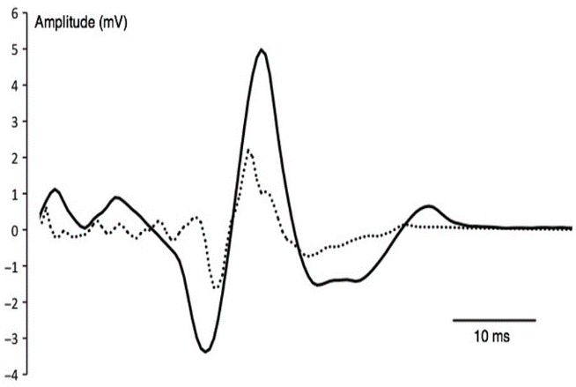
In this example, positive potentials are up, though graphic displays of EP often use a convention of negative potentials up. This image shows a normal somatosensory EP and is structurally similar to EP in other sensory modalities, with a central peak preceded and followed by a smaller peak with opposite sign. The smooth continuous curve is the result of signal averaging over hundreds of epochs, typically, each generated using the same stimulus with locked synchronization of the recording. High frequency noise is reduced by additional smoothing.

Comparison
In the GCP database each of the 500 formal events can be thought of as analogous to an epoch like those recorded in EP research on human sensory and neurophysiological systems. There is a stimulus in the form of an event that engages the attention of huge numbers of people. It may be terrorist attack or an earthquake or a mass meditation, but it serves to recruit attention and stimulate synchronous activity in millions of minds. Speculatively, but consistent with the data deviations that correspond to the event, it acts as a stimulus to a global consciousness. We’re obviously describing a creative model that differs little from pure poetry—unless we find in the data substantial reason to believe the model is apt and worth exploring. We already have some other indicators that support this kind of model. For example, an examination of the 500 GCP events aggregated in categories such as type of event, size, importance, emotional valence, emotional intensity, and specific emotions such as fear and compassion, shows that what we are identifying as global consciousness responds much the same way an individual human does in analogous situations. Another correspondence is that deviations linked with the identified global events are larger when people are awake than at night when they are more likely sleeping. On one level this isn’t a big surprise, yet considering that we aren’t talking about individual behavior, but an interaction on a global scale, it is thought provoking.
It appears that we may be able to describe another indicator of consonance between ordinary human consciousness and our hypothesized global consciousness. There is structure in the event data (at least in subsets of events that provide the best evidence of an effect) that is similar in form to what is seen when a sensory stimulus impinges on the human brain. The scale is very different, by a factor of 10 thousand or more. The human nervous system typically begins to respond within tens of milliseconds, and the full response to a single visual or auditory stimulus takes half a second or more. Our estimates of GC responses suggest a time period of a few hours. To take a particular example, comparing a half-second brain event to a 3-hour global event gives a ratio of a little over 1 to 20,000. Yet, when we compare responses of these systems with their wildly different scales, we see remarkable similarity in the defining structures.
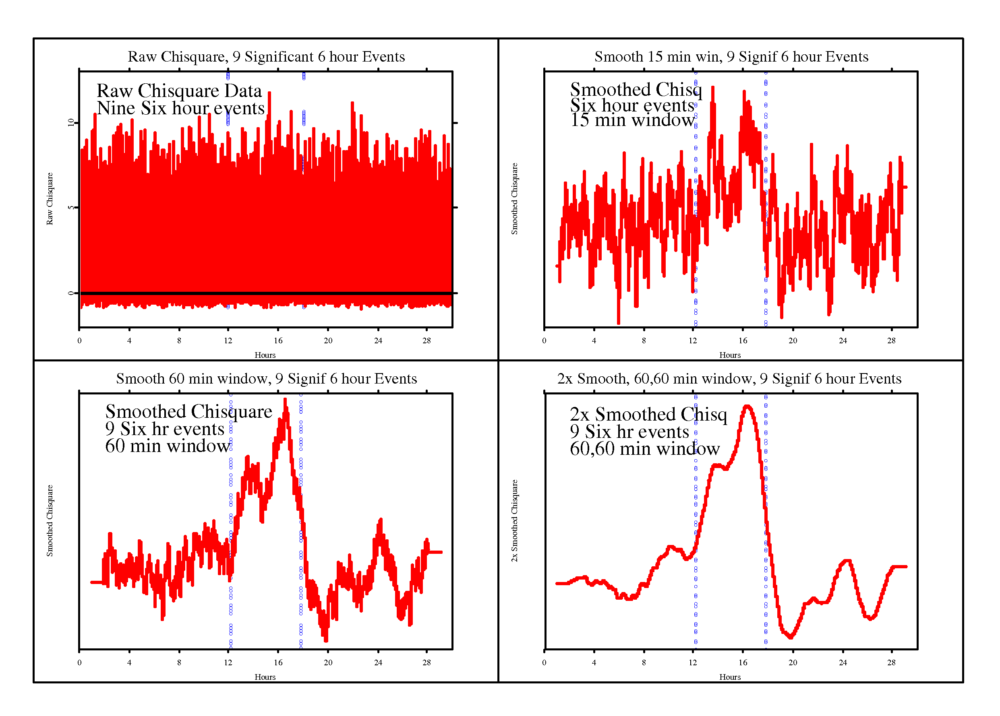
First, we return to the discussion of raw data versus the cumulative deviation data we ordinarily show in graphical presentations. To process GCP data in a way that is directly analogous to EP data, we must begin with the unprocessed Chisquare sequence representing the network variance response to global events. The upper left panel here shows the raw data for a composite of nine formal events that showed a significant deviation of the Netvar measure. These are all 6-hour events like the example above, but we are now signal averaging the events as described for evoked potentials. The other panels show three levels or stages of smoothing, to visualize how the process works.
The data from both research categories, EP and GCP, are noisy and require statistical finesse for analysis. In order to extract and display signals from the noise background, we use signal or epoch averaging. In brain research, hundreds of measures are taken with data recordings synchronized to the stimulus onset. When these are “stacked” on top of each other and averaged, the random noise tends to cancel and wash out, while any pattern that is linked to the stimulus will gradually build up to show the signal—the time-course of the brain response. Even with a large number of repetitions, the averaged data usually retain high-frequency noise, but this can be mitigated by smoothing. A window encompassing several sequential data points is averaged, then moved to the next point, progressively along the whole sequence. The result is a relatively smooth curve that represents the patterning of amplitude and direction of deviations from the background or baseline activity.
The following pair of figures allows a visual comparison of an EP graph with a GCP graph. The EP example, on the left, shows the evoked potential from an auditory stimulus. It is an example of data gathered in clinical research. (Anbarasi, 2019) The figure is described as a normal electrocochleaogram (OCoG) and it displays signal-averaged data from electrodes placed trans-tympanically into the cochlea. It uses the convention found in much of the evoked potential literature showing negative potentials upward. It is typical in displaying a large primary spike with smaller variations before and after, some of which are sufficiently distinct and regular as to be labeled.
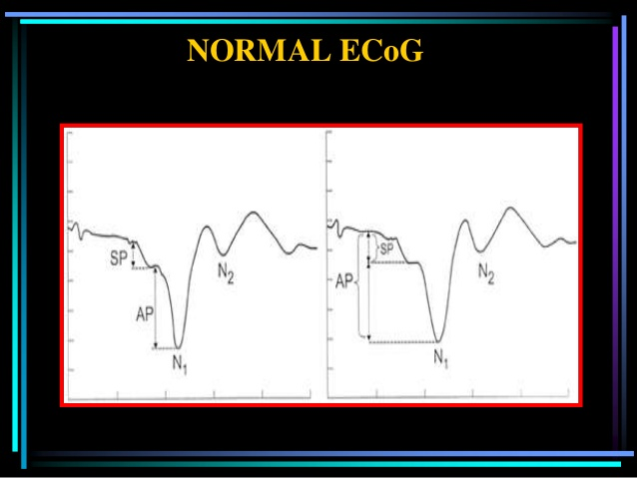
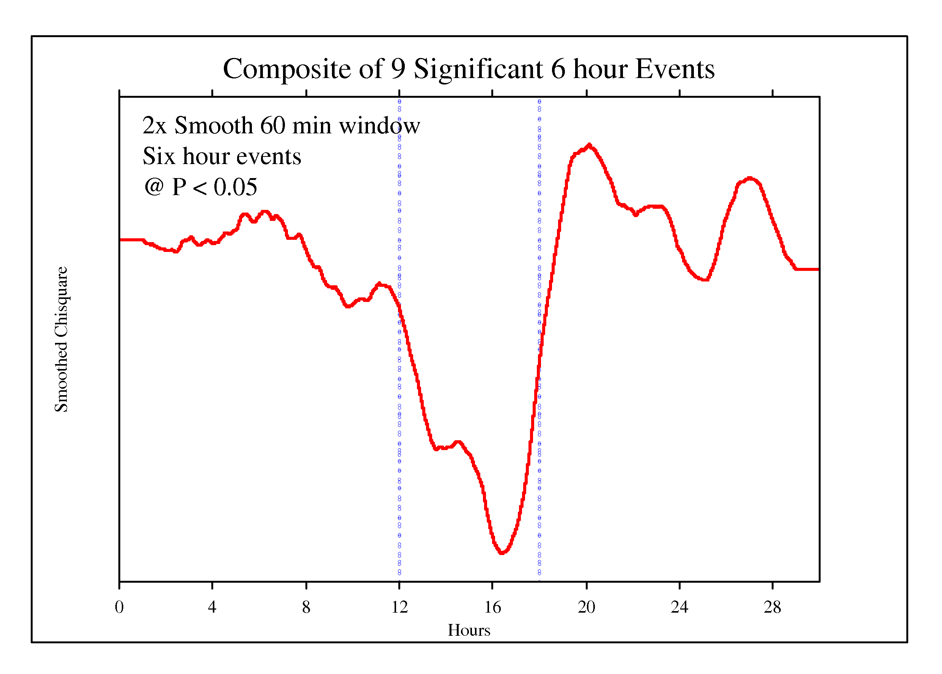
The right-hand figure is an example of GCP data treated in the same way. This is a composite of data from nine of the 6-hour events described earlier.
Signal Averaged Auditory EP Signal Averaged GCP Event Response
These were chosen because they show a clear effect as indicated by a significant terminal deviation. The whole dataset includes 12 hours before and after the event period, for a total of 30 hours. As described earlier and shown in the 4-panel figure, we use the raw data (Netvar measure at 1 per second) rather than the cumulative deviation of the Netvar, in order to parallel what is done in EP research. (You may recognize this figure as an inverted version of the one in the lower right of the 4-panel figure.) Following the analysis procedures for EP, the raw GCP data are smoothed with a moving (sliding) window long enough to reveal the major structure. For the 6-hour events, an appropriate window is 3600 seconds, High frequency noise is then mitigated by a second pass. The result is a smooth curve representing the major (low band pass) variations of the data during the events. The structure represents the common features across repeated measures of data deviations during major events.
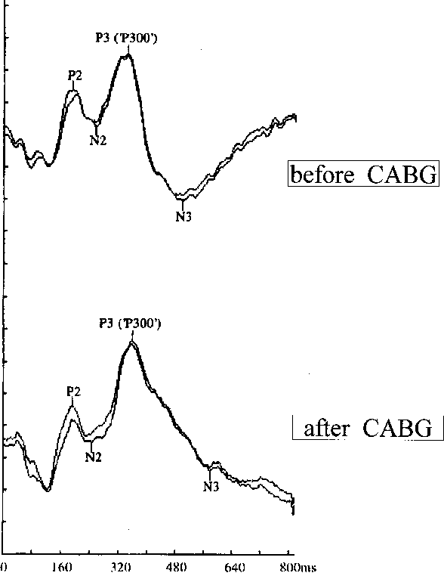
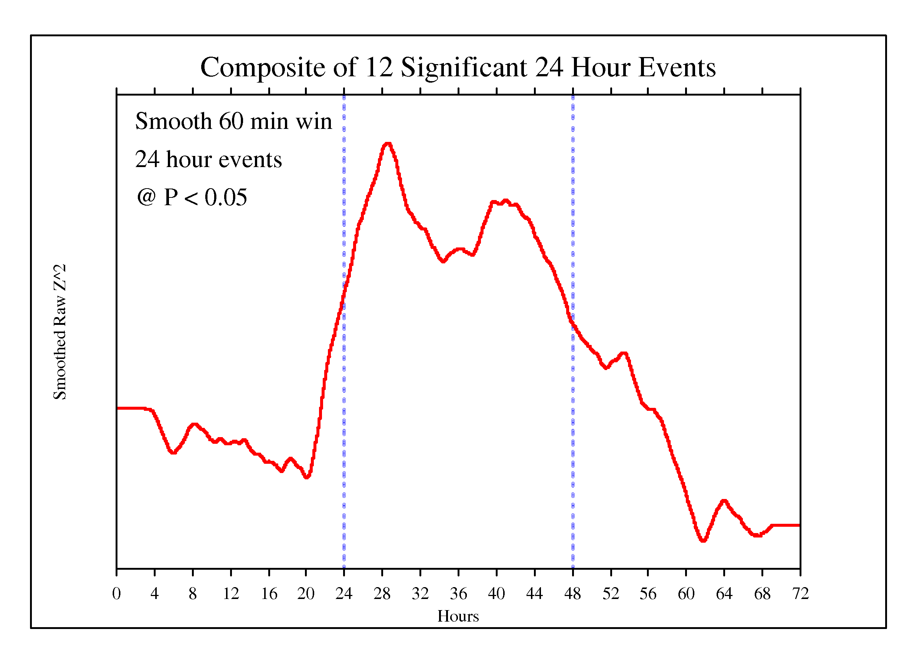
The signal averaging process was applied also to a sample of 24-hour events in the GCP database. There are 12 such events meeting the significance criterion, making them likely cases of a real effect correlated with the specified events. The 24-hour event data are surrounded on both sides by 24 hours of non-event data. The same kind of smoothing with a coarse and fine pass was used as for the 6-hour events, so the smooth curve represents a low band pass filtering of the raw data. For the EP comparison we show a positive-up trace of an auditory evoked potential. The visual matching in this case is not as close as in the 6-hour event example, but the variability of data in both domains is large even with statistical smoothing. EP research shows a wide variety of detailed graph shapes, but there is a common theme: small shifts in one direction, followed by a larger, primary shift in the opposite direction, then a return to baseline and often a small opposite peak or damping oscillation.
Signal Averaged Sensory EP Signal Averaged GCP Event Response

Interpretation
The GCP epochs averaged in the first comparison are 6 hours in duration, surrounded by 12 hours preceding and following the formal event. The “stimulus” is roughly at the beginning of the event period—in the 6-hour graph at about 12 hours. The stimulus in the 24-hour figure might be at the 24-hour point marked by the vertical line, but in most of these cases, is episodic or distributed over the 24-hour period.
Many interesting questions are brought into view by the comparison of EP vs Netvar structure. There are differences, of course, beyond those relating to scale and to physical vs statistical measurement. Yet it is worthwhile to think further about some of the questions. It seems important, given the fundamental character of the EP model, to consider what constitutes the “stimulus” to which the subsequent response is linked. In EP research that’s unambiguous—it is literally imposed by the experimental technology. In the GCP case, the stimulus isn’t quite so clear, though we can make a case that it is the point event to which the world responds. (This applies to the short, 6-hour events.) That, by definition, occurs near the beginning of the event, but is there a corresponding delay—the equivalent of the 10 to 50 ms in EP measures between the stimulus and the first big spike in voltage? In the examples shown here, such a delay isn’t easy to identify, though there is some structure that might qualify.
There are speculative suggestions that are worth considering. The events in the GCP experiment are in a strong sense internally defined. That is, the event only exists when it happens, so it is its own stimulus. It may also be of value to think of endogenous stimuli. For example, a decision to act, say, move a finger, may appear in the EP data before it appears in consciousness. We note that the 24-hour subset does show a building response before the 24-hour period begins. Only about 30 minutes of the 3-4-hour early buildup is attributable to the mathematical smoothing.
The primary research question is how any stimulus translates into a structured response in the random data from the GCP network. Why do our physical random devices become correlated at times when the thoughts and emotions of many humans become synchronized and coherent? The data say this is no accident or coincidence, and the experimental design ensures these correlations are meaningful. Do the intentions and expectation of researchers enter into the definition and execution of an experiment with results showing structure in what should be random data? There are multiple “explanations” for the small but highly significant data deviations, but thus far none is fully satisfying. Probably we need to look for explanations that recognize and integrate multiple sources.
Global Consciousness vs Goal Orientation
It seems appropriate to look at the material that stimulated this excursion into analogues for the GCP event data. Peter Bancel spent many years doing careful post hoc analysis on the GCP database looking for information and parameters to define a global consciousness (GC) model. He worked progressively toward demonstrations that generalized field models were a good fit to the data, and showed they were significantly better than another major contender, DAT-like selection models that posit precognitive information about future results driving present choices (e.g., when to start the experiment). (Bancel & Nelson, 2008; Nelson & Bancel, 2011) His most direct presentation of the case for field-like models was a 2013 paper submitted for presentation to the Parapsychological Association annual meeting. (Bancel, 2013) Not long thereafter, Peter reversed his position and began describing and promoting a goal orientation model (GO) that is essentially the DAT approach he had earlier rejected. (Bancel, 2014)
The GO model postulates psi-based experimenter selection of parameters, in particular the starting and ending points of the events. This model only addresses the primary measure, and is incapable of dealing with other structural elements of the GCP data, but Peter argues that GC can’t work, for technical and philosophical reasons. His argument is supported by a graphical analysis, shown in the left panel of the figure below. It is from a paper summarizing Peter’s views on the most suitable models for GCP findings. (Bancel, 2017)
The graph shows reversals at event boundaries that justify a preference for GO by conforming to an idealized selection model. The figure is a composite of all short GCP events, which nominally allow the experimenter to select start/end times. (This is in fact not the case for a large proporton of the events.) The proposal is that experimenter psi can achieve a desired future result by selecting from the natually varying data sequence an appropriate deviant segment. Further, Bancel argues that selecting points in the data sequence that define a positive segment will cause the preceding and following segments to show a deficit or a negative tendency: “If there is a choice on how to partition a null dataset, so that the chosen segment has a mean > 0, then the remaining segment will necessarily (on average) have a mean < 0. Choosing a start time is like this because the choices are all relatively proximate: You realistically might choose a time a minute earlier or later; or 15 minutes earlier or later; but not 12 hours or 12 days earlier or later.” (Bancel, 2016) I think this argument is fallacious – not least because it sounds like the gambler’s fallacy, (Bennet, 2019) given that the “null dataset” is by definition random, and is continuous over years. The “balancing” seen in the composite figure clearly needs a better explanation.
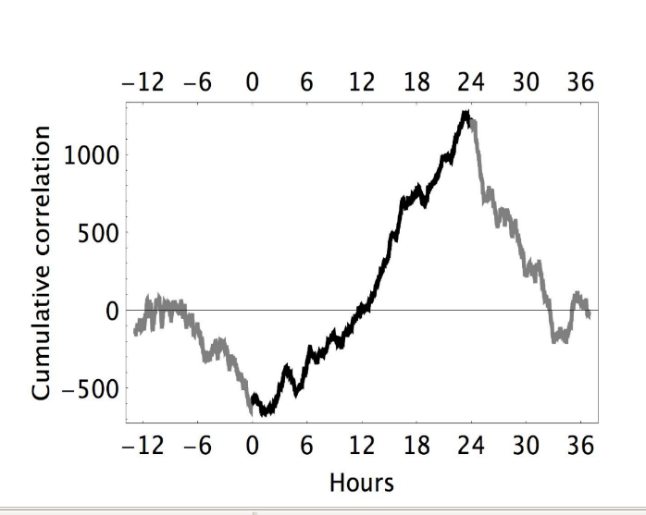
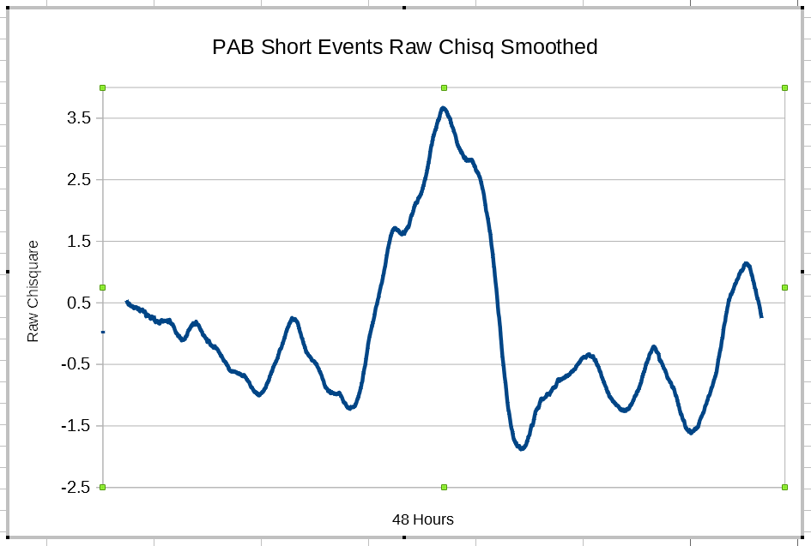
Something about this graphical presentation tugged at my unconscious for months—rooting around in old memories looking for images akin to this oscillating picture. Finally, it bubbled up to the surface. The graphic was reminiscent of event-related neurophysiological measures, which also show an oscillating response, albeit with a different shape. To see the connection more clearly it was necessary to revert to raw data, as described earlier. In order to process these data using the EP procedures, I decomposed Bancel’s original cumulative deviation figure to produce a file of equivalent raw data and proceeded with smoothing. The result is shown in the right hand figure below. It bears out my intuition that it should look like EP data.
Cumulative deviation, short GCP events Smoothed raw data, short GCP events
The cumulative deviation graph of the GCP “short” events shows sharply delineated inflections at the event boundaries, even though it includes a large proportion of null and negative outcome events, and still more events with previously determined, fixed parameters (there is no selection). The precision of the fit to the idealized model is intriguing and surprising, given the large proportion of events with fixed parameters or null and negative results. Perhaps the shape of the curve has another source than the proposed goal oriented psi data selection. The smoothed raw data graph, mimicing physiological EP measures, appears to suggest a viable candidate.
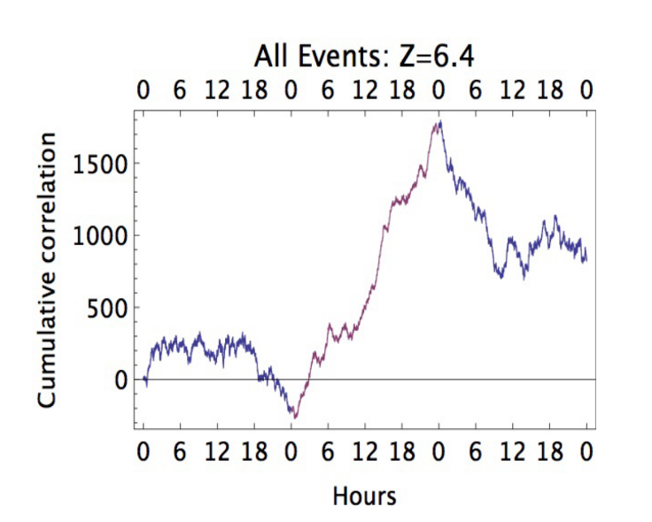
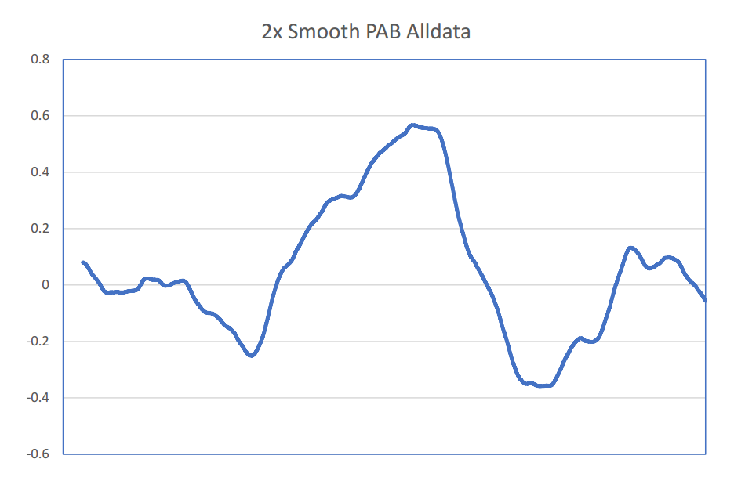
Peter made a similar figure for all the GCP data, first normalizing all the various event lengths to a 24-hour standard. A context of 24 hours before and after was included in the plot, and as in the case of the short event example, there are inflections at the event boundaries, and negative-going trends before and after. He argues that this supports the GO psi-selection model, but as in the previous case, there are many exceptions – events that explicitly do not conform to the required model criteria where selection is allowed. And again, there is an alternative “explanation” for the shape of the curve, namely, an event related potential model. The graph of smoothed raw data derived from the “all events” figure is practically indistinguishable from typical EP graphs.
72 Hours
Cumulative deviation, all GCP events Smoothed raw data, all GCP events
A Single Event
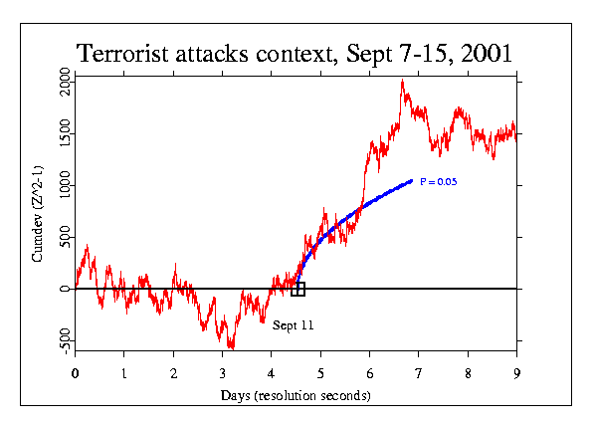
While the comparisons above depend on signal averaging across multiple events meeting a criterion of significance, we can ask if a sufficiently powerful individual event might show the same kind of structure. One that stands out in the GCP database is the terrorist attacks on Sept 11, 2001. The GCP network had been in place for three years and the number of Eggs had grown to 37, so the data recorded on September 11 were statistically robust. Because it was such a clear instance of an event that should instantiate the GCP hypothesis, we paid close attention. In addition to the a priori hypothesis test, we looked at other aspects of the event and did other analyses, including one extending the time period to include a context of 9 days around the event. The standard Netvar calculation was applied to data from Sept 7 to Sept 15. The slope of the cumulative deviation graph beginning when the first WTC tower was hit and continuing for nearly three days is extreme. An informal estimate for the probability lies between 0.003 and 0.0003 (this means an odds ratio on the order of 1 in 1000). Visual inspection suggests the trend begins as much as a day before the planes crashed into the World Trade Towers and continues for more than two days after the towers fell.

Though the time-scale differs, the cumulative deviation graph for this singular event presents a picture that is much like that seen for the signal-averaged events shown above, leading us to ask what structure the corresponding raw data might show when processed using the EP protocol and low band-pass filtering.

In the figure below (on the right) we see an answer to that question, which, as so often happens, leads to more questions. The smoothed raw data from the 9/11 context analysis does look like EP data, as can be seen here. It has the general form we have seen before, with a large deviation bracketed by smaller deviations of opposite sign. For a comparison, the left panel shows an example of evoked potentials recorded during tests of four cognitive processes: action-effect binding, stimulus-response linkage, action-effect feedback control, and effect-action retrieval. While I chose this picture because it is a good match, it is representative of a broad class of event-related potentials.
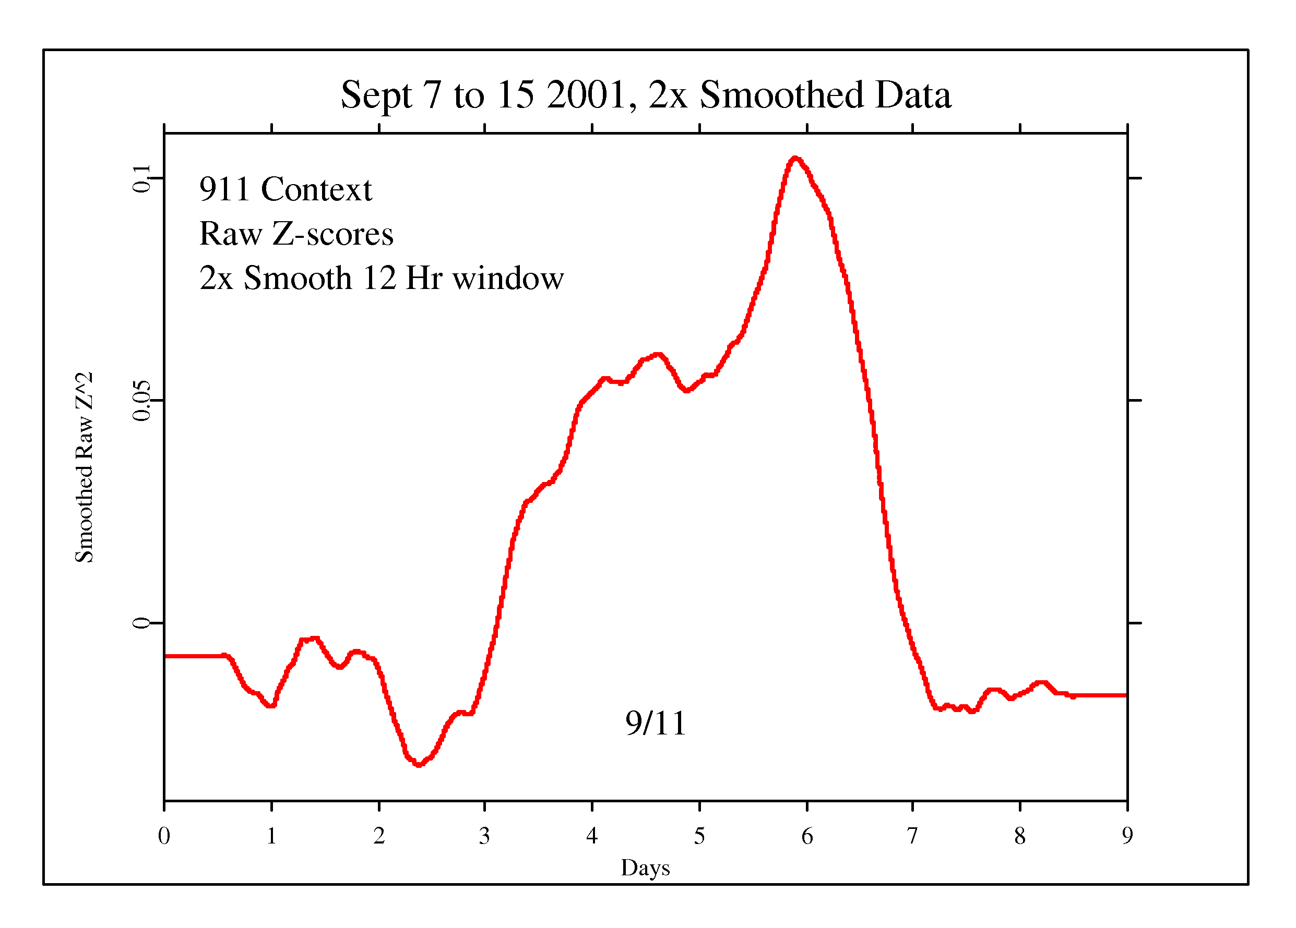
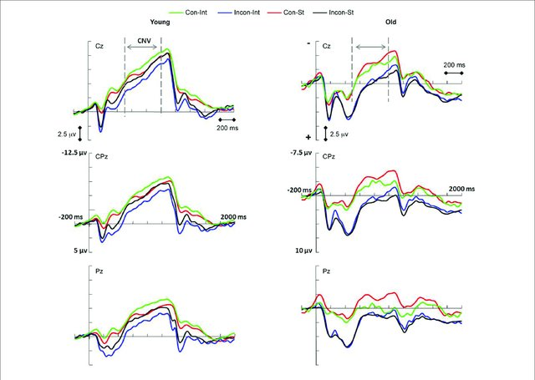
Contingent Negative Variation EP Smoothed raw data for 9 days around 9/11

Discussion
We have seen multiple examples of striking similarity between event-related brain potentials and event-related correlations in random data. Is the GCP network of widely distributed random number generators picking up something like the evoked responses of an earth-scale consciousness to powerful stimuli? If that idea is to be given serious consideration, how can the timing of the “response” be explained? It can’t be regarded as an immediate response to the terrorist attacks on 9/11 because the unequivocal changes begin more than a day earlier. Could the small group of 50 or 100 terrorists planning and working toward the attack be responsible? That would be counter to the experience and findings of the Field REG studies of group consciousness. And it would be inconsistent with the GCP database, where small numbers of people are associated with small effects. It is arguably just as likely that a global consciousness, whatever its nature, might have a presentiment of the future, given an emotionally powerful stimulus, just as humans do. (Radin, 2004) We can even calculate roughly the dimension of the former. The ratio of global-scale response times to the time-course of human perception is on the order of 20,000 to 1. (Nelson, 2019) The presentiment response shows up in physiological data on the order of 3 to 10 seconds before the stimulus. This corresponds in the GCP data to 0.7 to 2.3 days – in the same ball-park with the examples presented here.

These analyses are interesting on multiple levels, and they raise good questions. It is premature to claim the visual comparisons make a rigorous case akin to direct measures like recordings from the brain in EEG and EP work. We have only correlations and concordance. On the other hand, the conformance of event related GCP data responses to the general patterns of brain potentials responding to stimuli is noteworthy. All the examples we have seen support the idea that the GCP network reacts to the stimulus of global events with temporal variation that practically duplicates the response of neural networks to relevant sensory stimuli. This explanation for the shape of the GCP data curves is arguably better than the experimenter psi selection model proposed by Bancel. It is considerably more “down to earth” in that it requires no precognition of future system states to guide present choices. And there is no conundrum regarding events with fixed parameters or null and negative results. It is comfortably compatible with some temporally local field-like model. While we can’t formally describe a mechanism in this genre that can connect a mass consciousness response to the RNG network deviations, there is a clear, well-established correlation. Notably, if we take a serious look, that is all we have in the evoked potential case as well – just established correlations. Yet, neurophysiologists use EPs for diagnosis and treatment with no further ado.
Almost all psi research depends on statistical rather than direct measures. But it can be argued that correlation is a thing, “ein Ding an sich” and it is worth some effort to flesh out that proposition. (Atmanspacher, 2018) Can we draw an equivalence between statistical and physical measures? It is, at base, the same question as the more general one about information. Is it possible to formulate a relationship of information and energy that is like the one established early in the last century for energy and matter? If that happens, it will clarify important issues, not only in psi research but more broadly in science and philosophy.
Probably we will need a lot more data and much deeper thought to resolve such questions.

References
H. Atmanspacher (2018), “Synchronicity and the Experience of Psychophysical Correlations”, Chapter in Research in Analytical Psychology, Routledge.
M. Anbarasi, Auditory Evoked Potentials in Clinical Research, accessed Jan 19 2019, https://www.slideshare.net/anbarasirajkumar/evoked-potential-an-overview?next_slideshow=1
P. A. Bancel and R. D. Nelson (2008), “The GCP Event Experiment: Design, Analytical Methods, Results,” Journal of Scientific Exploration, no. 22 (n.d.): 309–333.

P. A. Bancel (2011), “Reply to May and Spottiswoode’s ‘The Global Consciousness Project: Identifying the Source of Psi,’” Journal of Scientific Exploration 25, no. 4.

P. A. Bancel (2013), “Is the Global Consciousness Project an ESP Experiment?” Submitted for presentation to the Parapsychological Association Annual Convention. (Affiliation: Institut Métapsychique International Paris, France).

P. A. Bancel (2014), “An Analysis of the Global Consciousness Project,” in Evidence for Psi: Thirteen Empirical Reports, Eds. Broderick & Goertzel (McFarland).
P. A. Bancel (2016), On suppression of adjacent data in a selection model, Personal communication, email, July 8 2016.
P.A. Bancel (2017), “Determining that the GCP is a Goal-Oriented Effect: A Short History”, Journal of Nonlocality, Vol 5, No 1.
R. Bennett (2019), “Logically Fallacious”, Accessed Feb 15 2019, https://www.logicallyfallacious.com/tools/lp/Bo/LogicalFallacies/98/Gambler-s-Fallacy
R. D. Nelson (2019), “Connected: The Emergence of Global Consciousness”, ICRL Press, Princeton, NJ.
R. D. Nelson and P. A. Bancel (2011), “Effects of Mass Consciousness: Changes in Random Data during Global Events,” Explore, The Journal of Science and Healing, 7, no. 6, pp 373–83.)

D. I. Radin (2004), “Electrodermal Presentiments of Future Emotions,” Journal of Scientific Exploration, Vol. 18, No. 2, pp. 253-273, 2004 0892-3310/04

